Student Attendance intake Function report

This report will show how the students capture their attendance in the order. The student's account details will be sent to them through admin email. Once the user receives it, they will be using it to login through the login page. Once, student's login they will see the login page below.

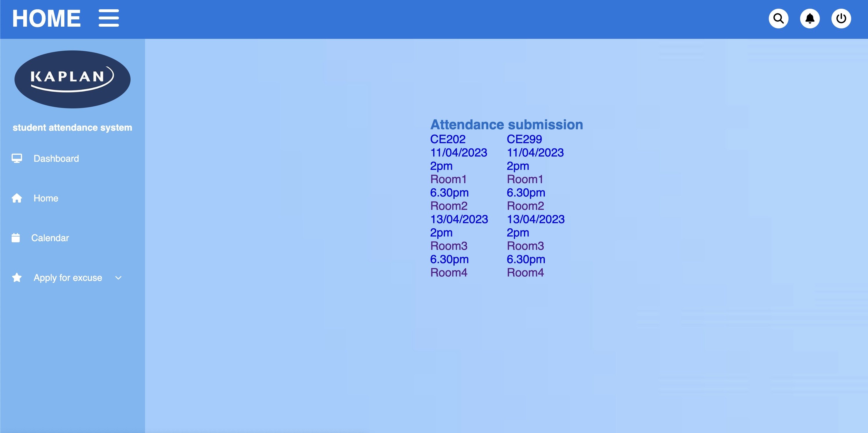

The flow of the submission will class code, date, time and finally location will be the trigger point for the submission.

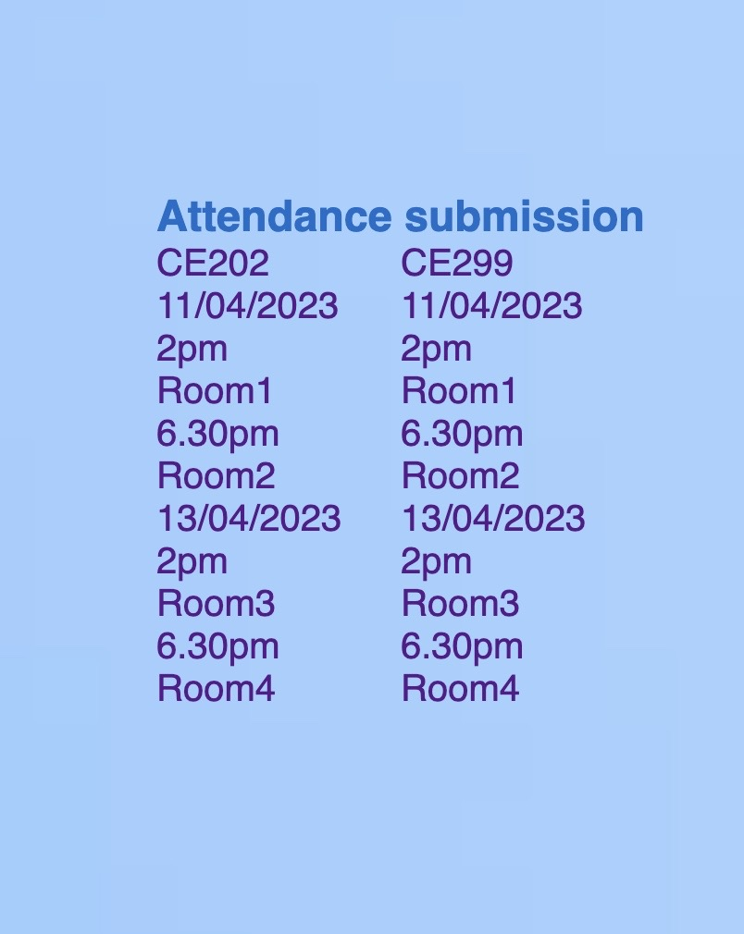

This setup will be using a drop-down menu which is easy and convent for students to submit their attendance. The students just need to select the details based on the classes with multiple options such as selection of dates for the day and upcoming dates followed by the time of the classes that happening on that date and lastly the location of the classes. The students only need to select the location of the classes to submit the attention. Once user selected, it will open the new page as shown below and show the following message.



If the students can see the following pop-up, then they have successfully submitted the attendance.